IPL

1. Find out when last IPL happened?

2. Find your LOADxx version number?

3. Find LOADxx identified in which PARMLIB library?

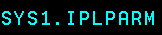

4. What is the IODF volume --unit address and vol=ser number?
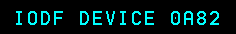

5. What is the SYSRES volume --unit address and vol=ser number?

6. What is the IEASYSxx version number?
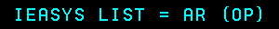

7. What is the IEASYMxx version number?
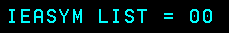

8. Find out concatenated parmlib library of your OS?

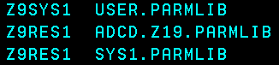

9. Find out your PROCLIB libraries for your OS?

10. List your LOADxx internal information like IODF name, Master catalog name, Nucleus ID, concatenated PARMLIB libraries etc?

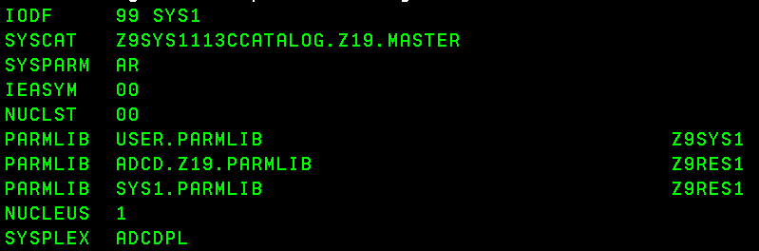

10. Find and list what is the type of IPL done on your system?

11. List important parmlib members version numbers from IEASYSxx?

12. What mode your JES2 is started?

13. What is your z/OS version?
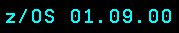
14. How many maximum users can log on to TSO/VTAM?

15. How much buffer size for CSA and SQA areas?

16. What are all the page datasets used in your system?

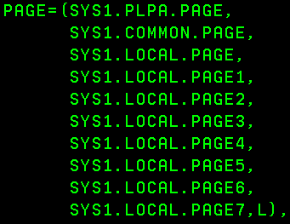
17. Find out your system name?
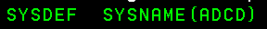
=============================================================================================

18. Using SYSLOG find out IPL process and list the order of execution? like from straing what exactly happened, parmlib member order and its parmlib library, order of subsystem startup.





